Budget Rent A Car 
of British Columbia

Global Information System

Rent Back & Interbranch Changes Business Design

Version 2.00

Note: The information contained in this document is confidential and may not be disclosed to any parties outside of Budget Rent a Car of British Columbia without written consent by one of its officers.
Copyright (C) 2000 Budget Rent a Car of British Columbia
Table of Contents
1. Functional Area Business Design 1
1.1. Contracts 1
1.1.1. Process Description 1
1.1.2. Screens 2
1.1.2.1. Contract Open/Check Out 2
1.1.2.1.1. Renter Tab 5
1.1.2.1.2. Rate Tab 8
1.1.2.1.3. Payment Tab 11
1.1.2.1.4. Comments Tab 17
1.1.2.2. Changes During Rental Screen 18
1.1.2.2.1. Extension Tab 21
1.1.2.2.2. Replace Vehicle Tab 24
1.1.2.2.3. Rate and Coverage Tab 27
1.1.2.2.4. Renter Tab 30
1.1.2.2.5. Comments Tab 30
1.1.2.2.6. Payment Tab 31
1.1.2.3. Contract Check In Screen 34
1.1.2.3.1. Check In Vehicle Tab 37
1.1.2.3.2. Payment Tab 40
1.1.2.3.3. Rate and Coverage Tab 45
1.1.2.3.4. Comments Tab 48
1.1.2.3.5. Renter Tab 49
1.1.2.4. Walk Up Information Screen 50
1.1.2.5. Additional Driver Screen 51
1.1.2.6. Truck Rental Availability Screen 52
1.1.2.7. Foreign Vehicle Availability Screen 52
1.1.2.8. Make Vehicle Available Screen 52
1.1.2.9. Rate Details Screen 52
1.1.2.10. Other Extras Screens 52
1.1.2.11. Manual Credit Card Transaction Screen 52
1.1.2.12. Direct Bill Search Screen 52
1.1.2.13. Rental Charge Billing Screen 53
1.1.2.13.1. Alternate Payment Details Sub-Screen (Loss of Use) 54
1.1.2.13.2. Alternate Payment Details Sub-Screen (Direct Bill) 54
1.1.2.13.3. Alternate Payment Details Sub-Screen (Voucher) 54
1.1.2.13.4. Split Rental Charge Sub-Screen 54
1.1.2.14. Deposit/Refund Record Screen 55
1.1.2.15. Discount / Reimbursement Screen 58
1.1.2.16. Extension History Screen 58
1.1.2.17. Vehicle Replacement History Screen 58
1.1.2.18. Coverage History 58
1.1.2.19. Non-GIS Rate Details Screen - New 59
1.1.3. Reports 64
1.1.4. Batch Processes 64
1.1.5. Functions 64
1.1.5.1. Calculate Non-GIS Rental Charges function 64
1.1.6. Summary of What GIS will Allow for Authorizations, Deposits, Payments & Collections Against Authorizations 65
2. Revision History 67
2.1. Version 2.00 67

Functional Area Business Design

Contracts
This is a description of the changes that will be made to the contract screens to accommodate the changes required to handle rent backs and interbranch for Part 1 of the Contracts Business Design. For reasons of clarity, the only changes that will be incorporated into the Contracts Part 1 Business Design document will be the ones that affect the behaviour and appearance of the contract screens for contracts with a Budget BC pick up location. This document will form the final business design for all the changes that relate to contracts with a foreign pick up location.
There are also a few changes in this document that are not specifically required to accommodate rent backs and interbranch, but which were identified and documented during the rent back meetings.

Process Description
No changes needed for rent backs or interbranch.

Screens

Contract Open/Check Out
BRAC Renting Location
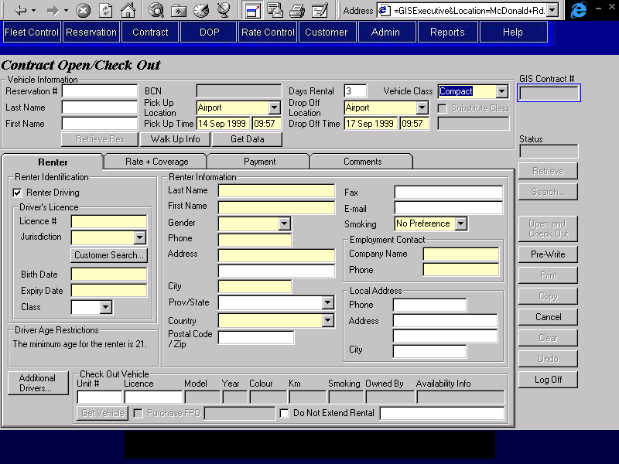
Non-BRAC Renting Location
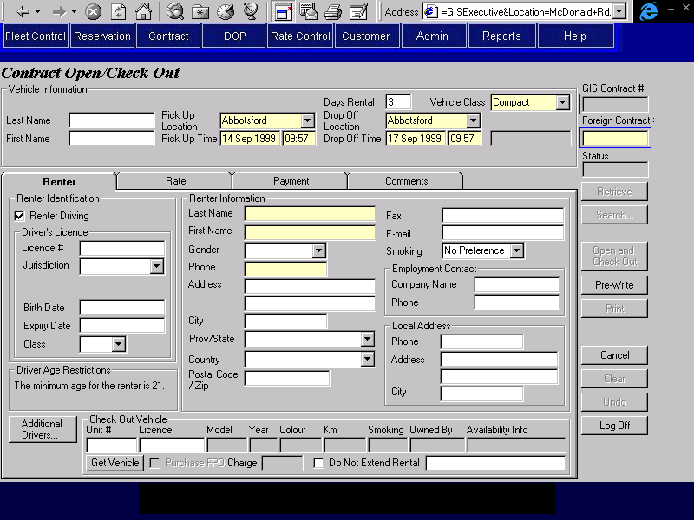
Summary of Changes
The label for the contract number field will be changed from ‘Contract #’ to ‘GIS Contract #’.
A new ‘Foreign Contract #’ field will be added. Both this field and the GIS Contract number will be searchable.
If the user is at a rental location, the only pick up locations available will be the current location and non-BRAC locations. If the user is at a non-rental location, all pick up locations will be available. Note that access to this screen will still be restricted by user ID.
If the renting location is BRAC:
- Foreign Contract # will be invisible.
If the renting location is not BRAC:
- Foreign Contract # will be enabled and visible and must be entered.
- The following controls will be invisible:
- Reservation Number
- BCN
- Retrieve Res button
- Walk Up Info button
- Substitute Class check box
- Copy button
- All drop off locations will be available. No checking of the valid drop off locations for the pick up location will be done.
- On Open:
The following edits will not be performed:
  - Edits for truck availability.
  - Any edits for the number of additional drivers.
  - Checking driver licence numbers entered against the ‘Do Not Rent’.
  - Any edits for driver licence expiry dates.
  - Minimum age edits for drivers and vehicle class.
  - Mandatory LDW checks for drivers under a certain age.
  - The pick up time will not be checked against the hours of business for the location.
When the contract is saved: ;
  - Truck availability will not be updated.

Renter Tab
BRAC Renting Location
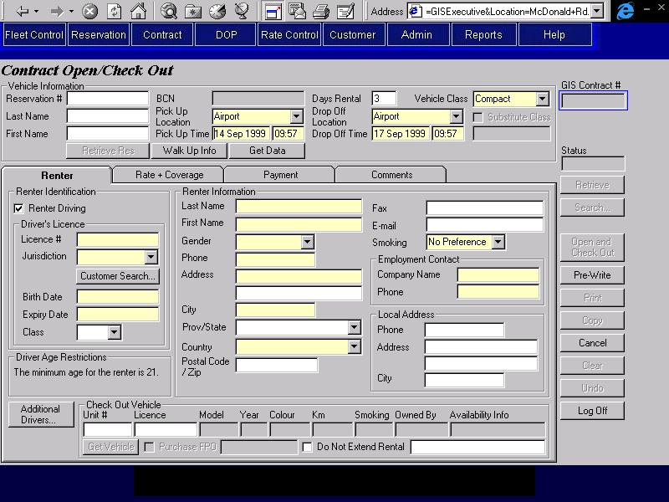
Non-BRAC Renting Location
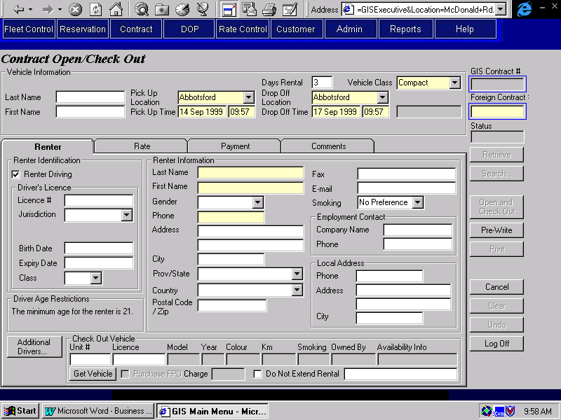
Summary of Changes
A new field, FPO Charge will be added immediately after the Purchase FPO check box. It will be a currency field.
If the renting location is BRAC:
- FPO Charge will be invisible.
If the renting location is not BRAC:
- All fields will be optional except for renter name and phone number. This includes driver licence and ID information for the renter. It is the renting location’s job to qualify the renter, not BRACs.
- The Customer Search button will be invisible.
- The calculated FPO charge will be invisible (and will not be calculated).
FPO Charge will be mandatory if Purchase FPO is on. It will be use to create a calculated charge item for FPO, using the amount entered.

Rate Tab
BRAC Renting Location
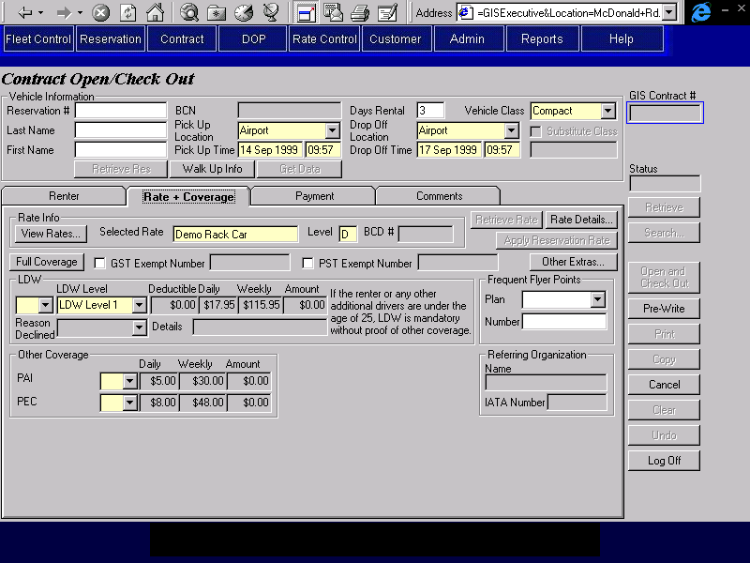
Non-BRAC Renting Location
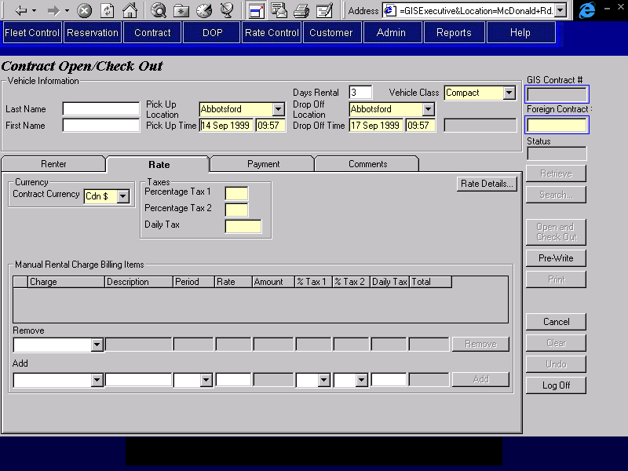
Summary of Changes
If the renting location is BRAC:
- Contract currency will default to Cdn $ and will not be displayed.
If the renting location is not BRAC:
- The tab name will display as ‘Rate’ instead of ‘Rate + Coverage’
- A different set of data will be displayed.
  - Contract Currency is mandatory and will default to Cdn $.
  - Percentage Tax 1, Percentage Tax 2 and Daily Tax are all mandatory, but can be entered as zero.
  - The Rate Details buttons will open the Non-GIS Rate Details screen, where rate information for the contract can be entered. This screen must be opened and the mandatory fields on the screen must be entered.
  - The Manual Rental Charge Billing Items section will behave as described in the Rental Charge Billing Screen.

Payment Tab
BRAC Renting Location
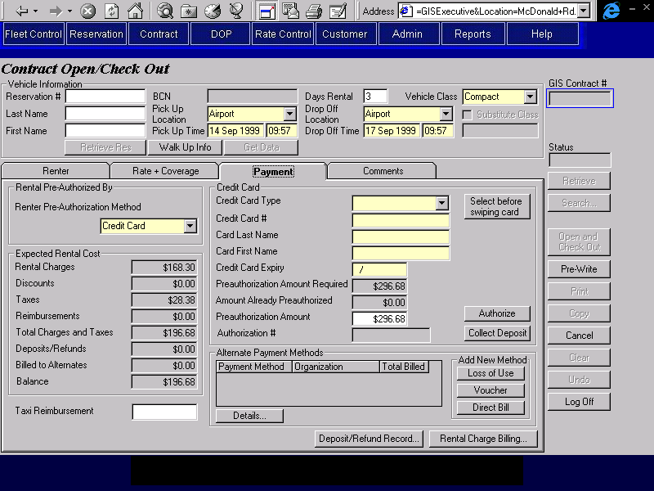

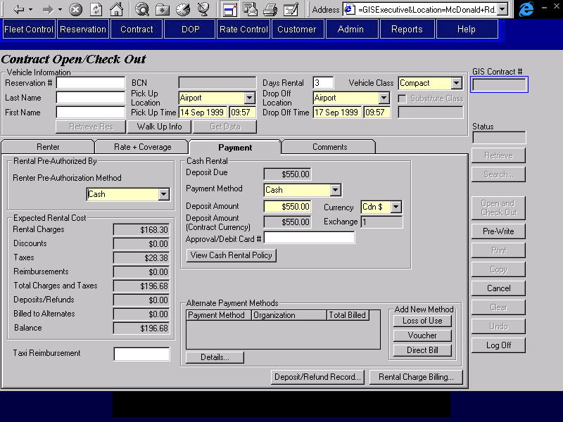

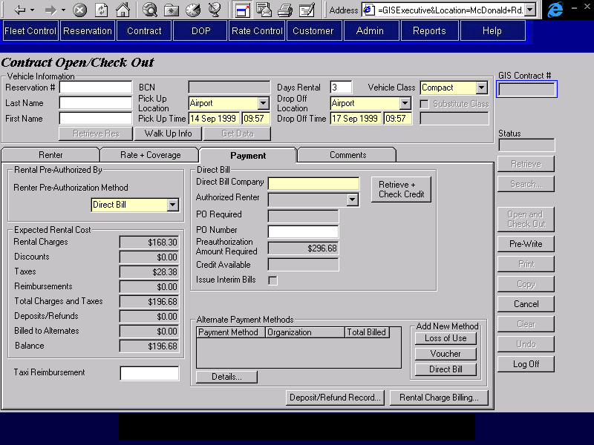
Non-BRAC Renting Location
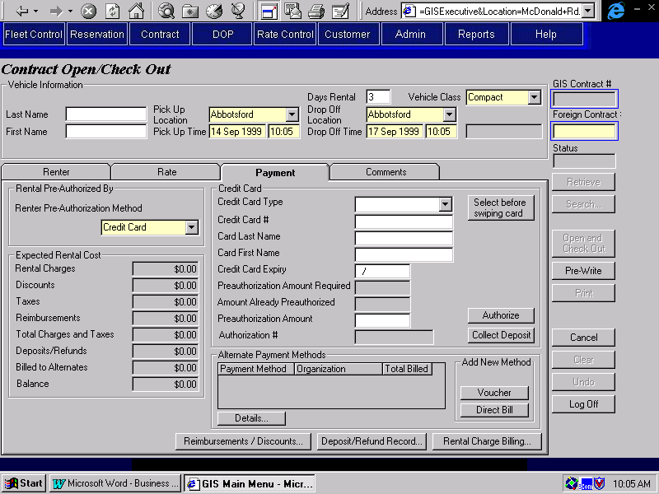

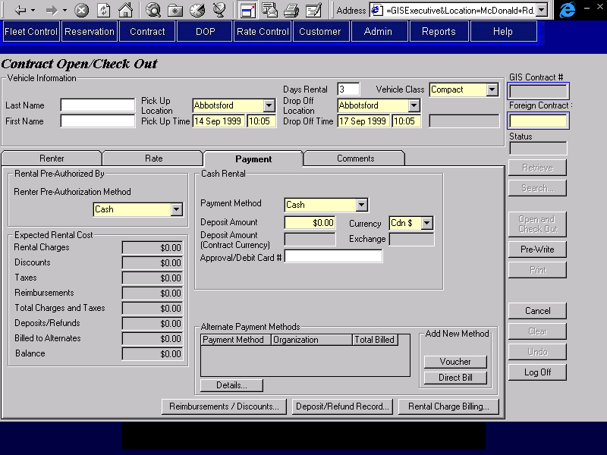
Summary of Changes
All authorization & deposit details entered in the payment tab will be recorded as have being taken at the renting location. They will be saved on GIS in the regular authorization and payment entities, but if the location does not belong to BRAC, the interface to accounting will be treated differently as these will represent payments against the contract, but not direct payments to BRAC. The Collected At Location is already recorded with payments and deposits, but GIS will have to be changed to record it with authorizations as well.
The currency for all credit card authorizations and deposits entered in this tab will be assumed to be the currency of the contract.
The currency for all cash deposit details entered in this tab will default to the currency of the contract. If another currency is selected, the deposit will be converted to the currency of the contract.
A button to allow access to the Reimbursements/Discounts screen will be added.
If the renting location is BRAC:
- The Reimbursements/Discounts button will be invisible.
- Credit Card Authorizations
The credit card information will be mandatory and will be locked when an authorization is processed against the card, or when the contract is saved, whichever comes first.
If the renting location is not BRAC:
- The Taxi Reimbursement field will be invisible.
- Credit Card Authorizations
The credit card information will be optional. Credit card authorizations and deposits can be recorded without it.
The Authorize & Collect Deposit buttons will open the manual credit card transaction screen regardless of the credit card type. The user will then be able to enter the amount and the authorization number on this screen.
- Cash Authorizations
The View Cash Rental Policy button will be invisible (qualifying the cash rental is the responsibility of the renting location, not BRAC).
Deposit Due will be invisible.
Deposit Amount will not default to Deposit Due.
- Direct Bill Authorizations
The Direct Bill option will be invisible.
- Alternate Payment Methods
The Loss of Use button will be invisible. The only alternate payment methods that can be added are Voucher and Direct Bill and the only valid company to bill to is the renting location. Limiting the company to the renting location will be a procedural issue.
- If the Rental Charge Billing screen is opened from this tab, the Manual Rental Charge Billing section will be visible and enterable. This will allow the entry of charge items that do not fit into the Non-GIS Rate Information screen.
- The Calculate Rental Charges function will use the non-GIS information entered on the Rate tab to calculate charges. For details on the calculation process, see the Calculate Non-GIS Rental Charges function description.

Comments Tab
Summary of Changes
No changes needed for rent backs or interbranch.

Changes During Rental Screen
BRAC Renting Location
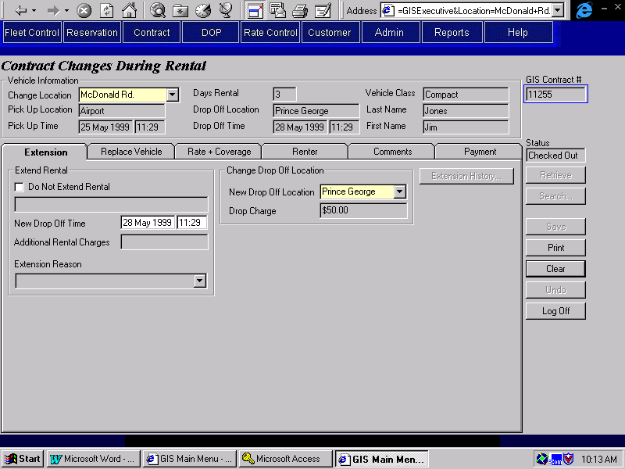
Non-BRAC Renting Location
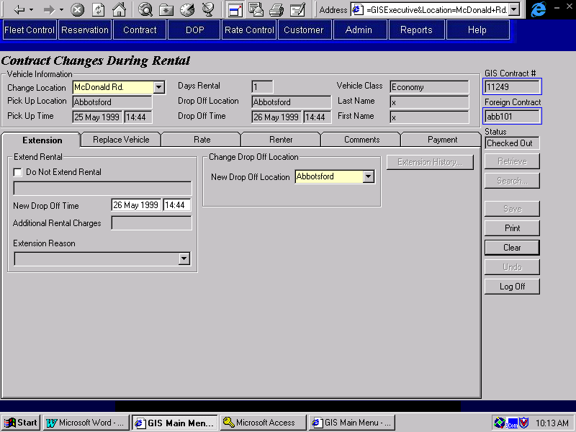
Summary of Changes
The label for the contract number field will be changed from ‘Contract #’ to ‘GIS Contract #’.
A new ‘Foreign Contract #’ field will be added. Both this field and the GIS Contract number will be searchable.
A new field, Change Location will be added to the top of the screen in the place of BCN. This location will be the location where all changes are made. It will replace the Switch Location in the Replace Vehicle tab and the Locations fields for removing and adding coverage in the Rate + Coverage tab. This will also become the location where authorization & deposit details entered in the payment tab will be assumed to have been taken and will be the default location for all transactions in the Deposit/Refund screen.
If the renting location is BRAC:
- Foreign Contract # will be invisible.
If the renting location is not BRAC:
- Foreign Contract # will be enabled and visible.
- On Save:
The following edits will not be performed:
  - Edits for truck availability.
  - Any edits for the number of additional drivers.
  - Checking driver licence numbers entered against the ‘Do Not Rent’.
  - Any edits for driver licence expiry dates.
  - Minimum age edits for drivers and vehicle class.
  - Mandatory LDW checks for drivers under a certain age.
  - The pick up time will not be checked against the hours of business for the location.
When the contract is saved.
  - Truck availability will not be updated.

Extension Tab
BRAC Renting Location
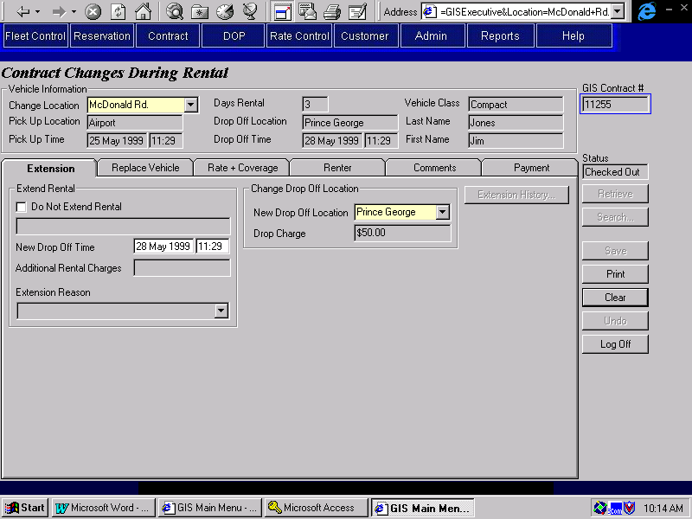
Non-BRAC Renting Location
Summary of Changes
If the renting location is not BRAC:
- The Truck Rental Availability button will never be visible.
- The violation rate in effect section will never be visible.
- No checking for unauthorized drop off locations will be done and the Drop Charge will not be calculated and displayed by GIS when the Drop Off Location is changed. If there is a new drop charge, it will be added manually as a Manual Charge Item through the Rental Charge Billing screen.
- If the rental period is extended or shortened, charges for any Manual Charge Items on the Rental Charge Billing screen that have a period of Daily or Weekly will automatically be updated to fit the new rental period. Any Manual Charge Items that have a period of Flat will not be automatically updated.

Replace Vehicle Tab
BRAC Renting Location
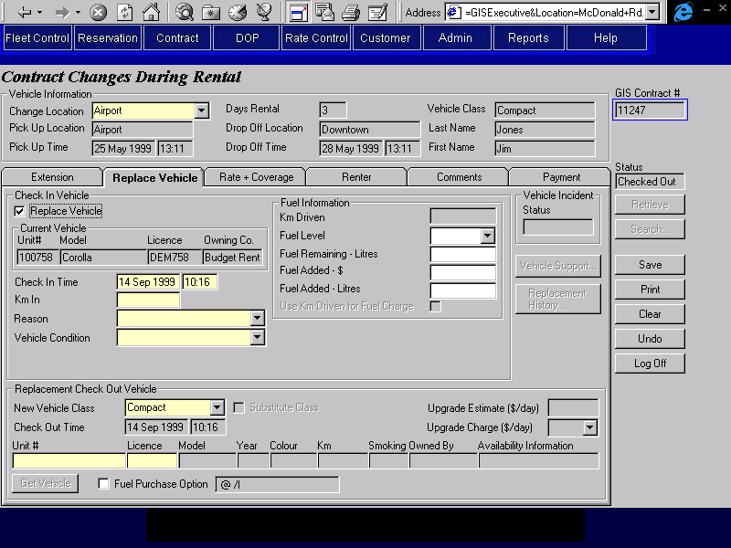
Non-BRAC Renting Location
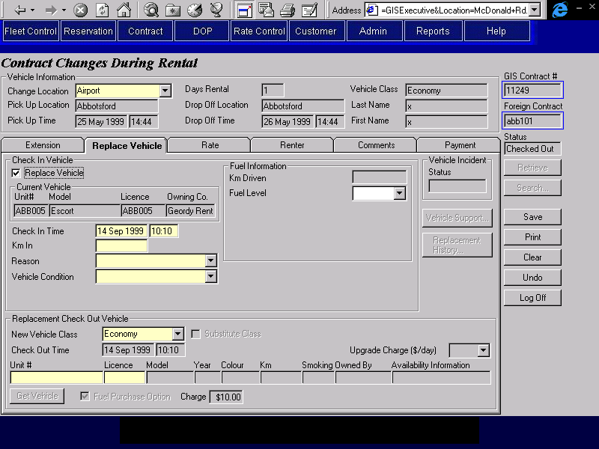
Summary of Changes
The Switch Location field will be replaced by the Change Location field at the top of the screen.
A Replacement Contract # will be added to the Replace Vehicle sections. It will be entered when a Budget BC vehicle is replaced by a foreign vehicle (or vice versa). This field will be used to determine the revenue split between the two owning companies. It will not be used by GIS.
A new field, FPO Charge will be added immediately after the Purchase FPO check box. It will be a currency field.
For non FPO fuel fields:
If the change location is not BRAC then only the Fuel Added ($) field will be enabled.
If the change location is BRAC and the vehicle is a foreign vehicle then only the Fuel Added ($) field and the Fuel Added ($) field will be enabled.
Otherwise if the change location and the vehicle is BRAC then all the fuel fields will be enabled.
If the original and replacement vehicles have different owning companies:
- Replacement Contract # (Vehicle On Contract, Replacement Contract Number) will be enterable, but not mandatory. A message will be displayed telling the CSR to enter the contract number for the contract opened by the switch location.
- When there is also a contract number for the owning company of a vehicle used in a switch, it will be recorded as an internal contract comment. This will be procedural issue and will not be enforced by GIS.
If the renting location is BRAC:
- FPO Charge will be invisible.
If the renting location is not BRAC:
- The Truck Rental Availability button will never be visible.
- The CSR will still be able to turn the Substitute Class check box on and enter an Upgrade Charge, but GIS will not calculate or display an Upgrade Comparison.
- The calculated FPO charge will be invisible (and will not be calculated).
FPO Charge will be mandatory if Purchase FPO is on. It will be use to create a calculated charge item for FPO, using the amount entered.
- If the vehicle class is changed, no minimum age checks will be done for the drivers, or for mandatory LDW.

Rate and Coverage Tab
BRAC Renting Location
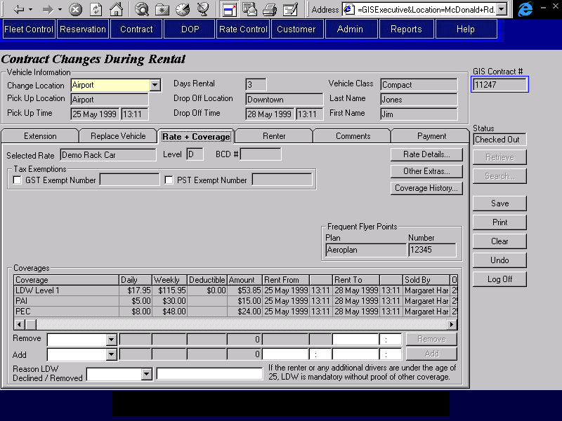
Non-BRAC Renting Location
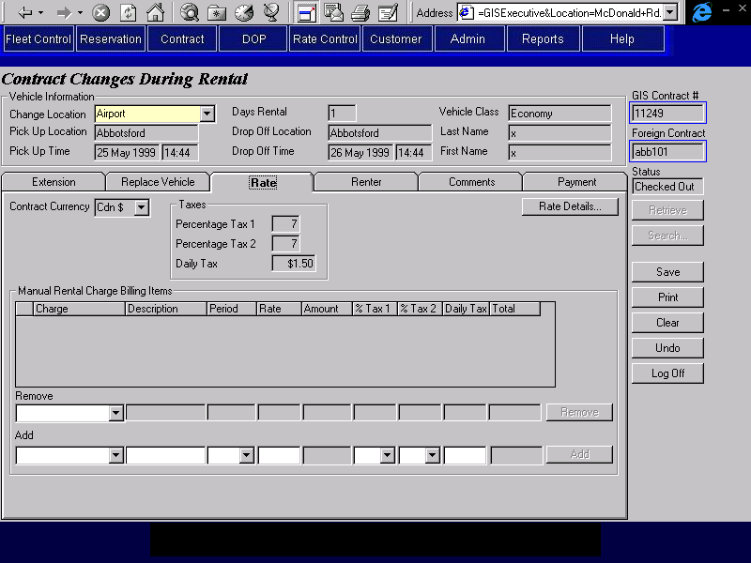
Summary of Changes
The Location fields for adding and removing coverages will be replaced by the Change Location field at the top of the screen.
If the renting location is not BRAC:
- The tab name will display as ‘Rate’ instead of ‘Rate + Coverage’
- A different set of data will be displayed. Except for the Manual Rental Charge Billing section, none of the fields will be updateable.
  - Contract Currency.
  - Percentage Tax 1, Percentage Tax 2 and Daily Tax.
  - The Rate Details buttons will open the Non-GIS Rate Details screen, where rate information for the contract can be viewed (but not changed).
  - The Manual Rental Charge Billing Items frame will behave as described in the Rental Charge Billing Screen.

Renter Tab
Summary of Changes
No changes needed for rent backs or interbranch.

Comments Tab
Summary of Changes
No changes needed for rent backs or interbranch.

Payment Tab
BRAC Renting Location
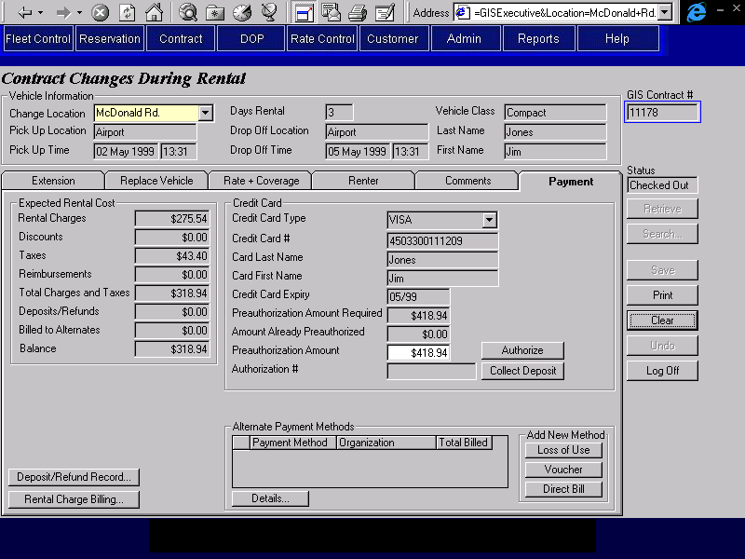
Non-BRAC Renting Location
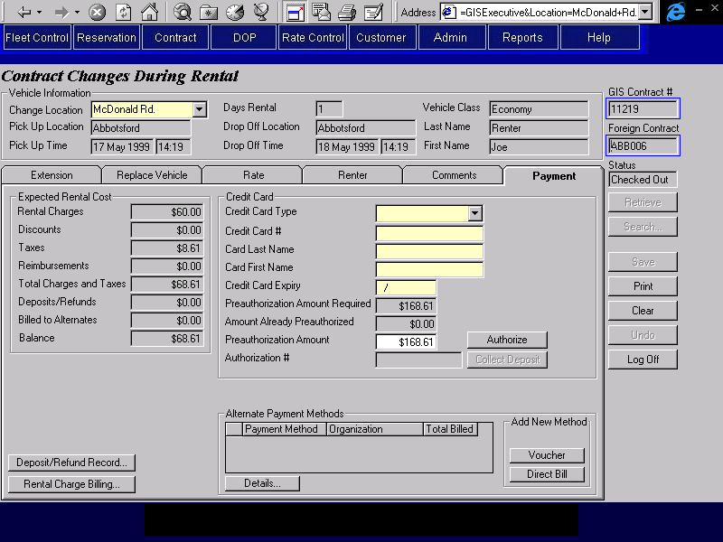
Summary of Changes
All authorization & deposit details entered in the payment tab will be recorded as having been taken at the change location. They will be saved on GIS in the regular authorization and payment entities, but if the location does not belong to BRAC, the interface to accounting will be treated differently as these will represent payments against the contract, but not direct payments to BRAC. The Collected At Location is already recorded with payments and deposits, but GIS will have to be changed to record it with authorizations as well.
The currency for all credit card authorizations and deposits entered in this tab will be assumed to be the currency of the contract.
The currency for all cash deposit details entered in this tab will default to the currency of the contract. If another currency is selected, the deposit will be converted to the currency of the contract.
If the renting location is BRAC:
- Credit Card Authorizations
The credit card fields will have been entered during Contract Open/Check Out and will be locked.
If the change location is not BRAC, the Authorize & Collect Deposit buttons will open the manual credit card transaction screen regardless of the credit card type. The user will then be able to enter the amount and the authorization number on this screen.
If the renting location is not BRAC:
- Credit Card Authorizations
Any fields already be populated will be locked.
  - If the change location is BRAC:
The credit card fields will be enterable (and must be entered if an authorization or deposit is processed against the card used to authorize the rental). If an authorization or deposit is processed against the card or on Save, the populated credit card fields will be locked.
  - If the change location is not BRAC:
The credit card fields will be optional (except for credit card type).
The Authorize & Collect Deposit buttons will open the manual credit card transaction screen regardless of the credit card type. The user will then be able to enter the amount and the authorization number on this screen.
- Alternate Payment Methods
The Loss of Use button will be invisible. The only alternate payment methods that can be added are Voucher and Direct Bill and the only valid company to bill to is the renting location. Limiting the company to the renting location will be a procedural issue.
- If the contract is in a foreign currency, credit card payments and refunds at other locations can be recorded, no credit card payments can be collected or refunds issued at BRAC locations.
- The Calculate Rental Charges function will use the non-GIS information from the Rate tab to calculate charges. For details on the calculation process, see the Calculate Non-GIS Rental Charges function description.

Contract Check In Screen
BRAC Renting Location
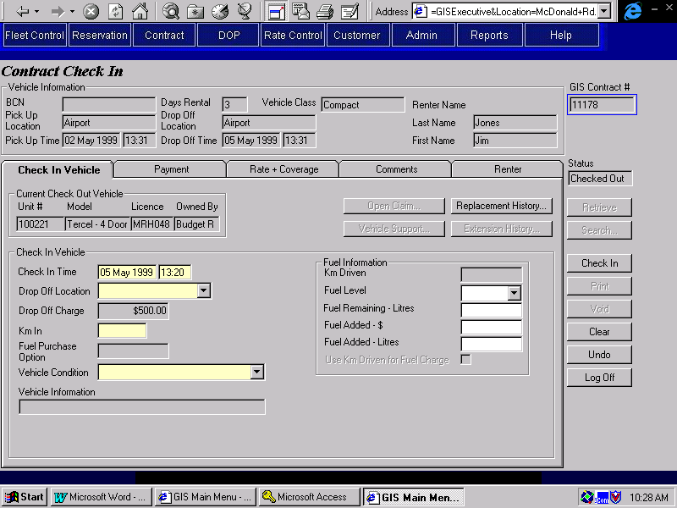
Non-BRAC Renting Location
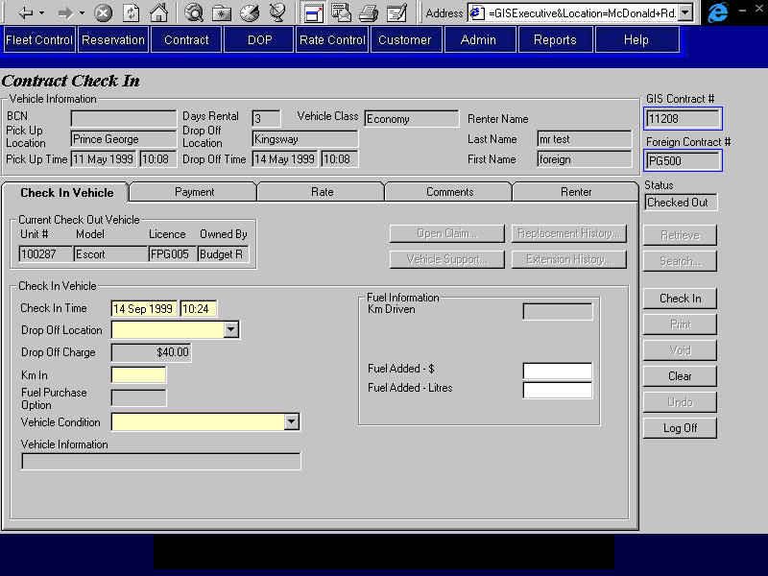
Summary of Changes
The label for the contract number field will be changed from ‘Contract #’ to ‘GIS Contract #’.
A new ‘Foreign Contract #’ field will be added. Both this field and the GIS Contract number will be searchable.
If the Check In Location is BRAC:
If the vehicle model of the vehicle being checked in is a foreign model with no fuel tank size, the Fuel Added-$ field and the Fuel Added (litres) will be enabled and GIS will not try to automatically calculate the fuel charges based on the vehicle model. Note that this change is required for all contracts, not just for rent backs.
If the Check In Location is Foreign only the Fuel Added-$ field will be enabled. Again GIS will not try to automatically calculate the fuel charges based on the vehicle model. Note that this change is required for all contracts, not just for rent backs.
If any of the data entered at check in results in the calculated rental charges being updated and if any of the calculated rental charges that were updated had been assigned to a third party, a warning message will be displayed telling the CSR that they will have to reassign the calculated rental charges to the third party(ies). Note: this change comes from the rental charge billing redesign, not from rent backs but was documented in a rent back meeting.
If the renting location is BRAC:
- Foreign Contract # will be invisible.
If the renting location is not BRAC:
- Foreign Contract # will be enabled and visible.
- On Save:
  - Truck availability will not be updated.
  - No Customer Profile information will be added or updated.
- On Void:
  - Truck availability will not be updated.

Check In Vehicle Tab
BRAC Renting Location
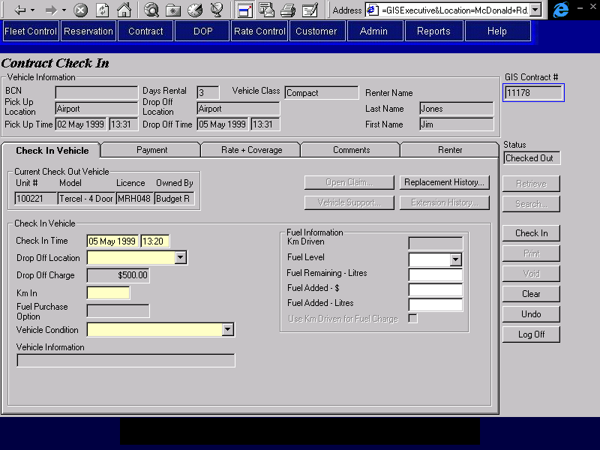
Non-BRAC Renting Location
Summary of Changes
If the renting location is not BRAC:
- The violation rate in effect section will never be visible.
- No checking for unauthorized drop off locations will be done and no unauthorized Drop Charge will be calculated by GIS when the Check In Location is not the expected Drop Off Location. The drop off charge displayed on the tab is that entered in the rate tab. If there is an unauthorized drop charge, it will be added manually as a Manual Charge Item through the Rental Charge Billing screen.
- If the check in is earlier or later than expected, charges for any Manual Charge Items on the Rental Charge Billing screen that have a period of Daily or Weekly will automatically be updated to fit the new rental period. Any Manual Charge Items that have a period of Flat will not be automatically updated.
- If the actual drop off location is not the expected drop off location, a warning message will be displayed advising the CSR to check with the renting location in case unauthorized drop charges apply.

Payment Tab
BRAC Renting Location
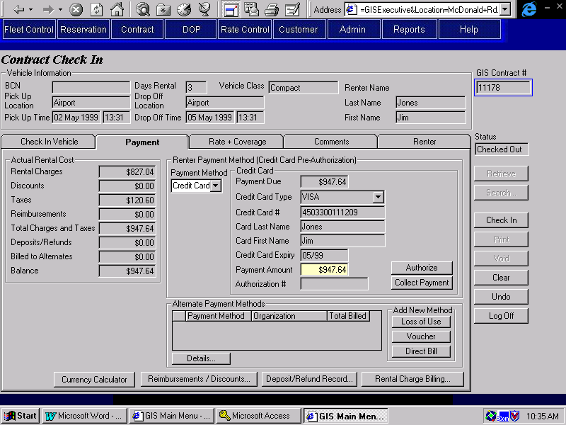
Non-BRAC Renting Location
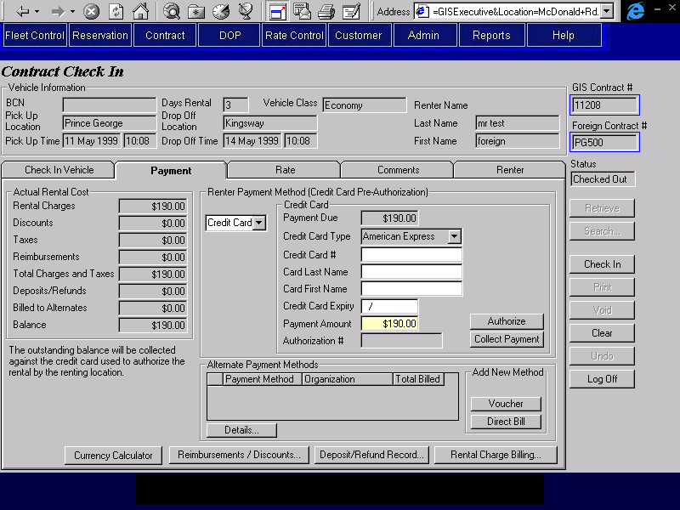
Summary of Changes
Authorization & payment details entered in the payment tab will be recorded as having been taken at the check in location. They will be saved on GIS in the regular authorization and payment entities, but if the location does not belong to BRAC, the posting to accounting will be treated differently as these will represent payments against the contract, but not direct payments to BRAC.
An Authorize button will be added to the frame displayed for rentals that were authorized with a credit card authorization.
If the renting location is BRAC:
- Credit Card Authorizations
The credit card fields will have been entered during Contract Open/Check Out and will be locked.
  - If the check in location is BRAC:
The Authorize button will be invisible.
  - If the check in location is not BRAC:
The Authorize button will open the manual credit card transaction screen regardless of the credit card type. The user will then be able to enter the amount and the authorization number on this screen
If the renting location is not BRAC:
- Credit Card Authorizations
Any fields already populated will be locked.
  - If the check in location is BRAC
    - If no deposits of any kind have been collected during the rental:
The Collect Payment button will be invisible.
The following message will be displayed:
‘The outstanding balance will be collected by the renting location, against the credit card used to authorize the rental’.
The CSR will still need to authorize an additional amount if the amount owing exceeds the original authorization. This will be a procedural issue and will not be enforced by GIS.
Any outstanding balance for the contract will be saved in Interbranch Balance, a new field on the Contract. This will be used by the Adjustments screen to ensure that we are not forced to collect this balance if an adjustment is entered for a parking ticket, etc.
    - Any credit card fields that are not already populated will be enterable (and must be entered if an authorization is processed against the card used to authorize the rental). Any fields that are already populated will be locked.
  - If the check in location is not BRAC:
Any credit card fields that are not already populated will be enterable (but optional). Any fields that are already populated will be locked.
The Authorize & Collect Payment buttons will open the manual credit card transaction screen regardless of the credit card type. The user will then be able to enter the amount and the authorization number on this screen.
- Cash Authorizations
If the contract currency is US$, the Mail Refund button will not be visible.
- Alternate Payment Methods
The Loss of Use button will be invisible. The only alternate payment methods that can be added are Voucher and Direct Bill and the only valid company to bill to is the renting location. Limiting the company to the renting location will be a procedural issue.
- If the check in location is BRAC and the rental was authorized with a credit card pre-authorization (not a credit card deposit), no payment can be collected against that credit card. If the outstanding balance is greater than the sum of the authorizations, an additional authorization should be done.
- If the contract is in a foreign currency, credit card payments and refunds at other locations can be recorded, no credit card payments can be collected or refunds if the check in location is BRAC.
- If the rental was authorized with a credit card authorization, no deposits have been collected and there is an outstanding balance that is less than the amount authorized, a message will be displayed advising the CSR that the outstanding balance will be collected by the renting location and does not have to be collected by the closing location.
- The Calculate Rental Charges function will use the non-GIS information from the Rate tab to calculate charges. For details on the calculation process, see the Calculate Non-GIS Rental Charges function description.
If the check in location is not BRAC
- Credit Card Authorizations
Any credit card fields that are not already populated will be enterable (but optional). Any fields that are already populated will be locked.
The Authorize & Collect Payment buttons will open the manual credit card transaction screen regardless of the credit card type. The user will then be able to enter the amount and the authorization number on this screen. Note that if the renting location is BRAC, or if any transactions for this credit card have been processed at a BRAC location, these fields will already be populated and will be locked.

Rate and Coverage Tab
BRAC Renting Location
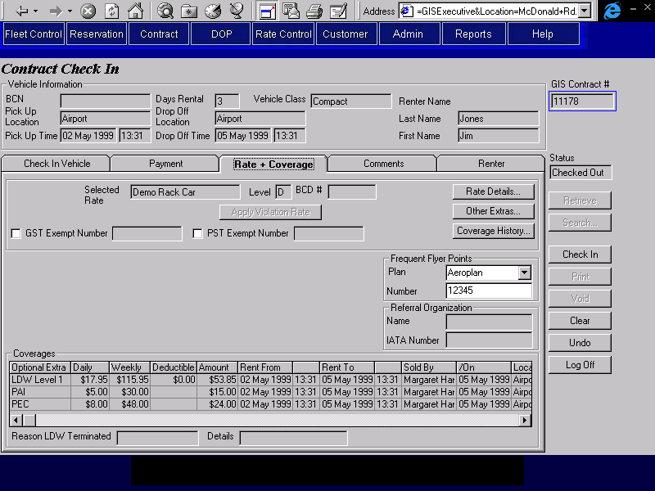
Non-BRAC Renting Location
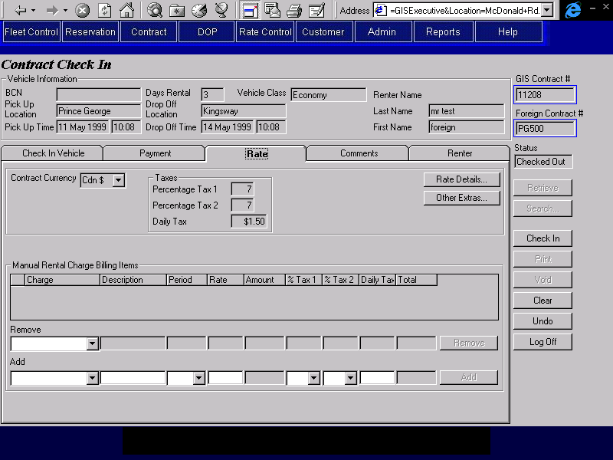
Summary of Changes
If the renting location is not BRAC:
- The tab name will display as ‘Rate’ instead of ‘Rate + Coverage’
- A different set of data will be displayed. Except for the Manual Rental Charge Billing Items, none of the fields will be updateable.
  - Contract Currency.
  - Daily Percentage Tax 1, Daily Percentage Tax 2 and Daily Tax.
  - The Rate Details buttons will open the Non-GIS Rate Details screen, where rate information for the contract can be viewed (but not changed).
  - The Manual Rental Charge Billing Items frame will behave as described in the Rental Charge Billing Screen.

Comments Tab
Summary of Changes
No changes needed for rent backs or interbranch.

Renter Tab
Summary of Changes
If the renting location is not BRAC:
- None of the enterable fields are mandatory.

Walk Up Information Screen
Summary of Changes
No changes needed for rent backs or interbranch.

Additional Driver Screen
Summary of Changes
If the renting location is not BRAC:
- The only mandatory fields are type, last name, first name and valid from & to dates. Note that for company additional drivers last name and first name are not required.
- The Search Customer button will be invisible.
- No rental charge items will be created for additional drivers. Additional driver charges will have to be added to the contract as manual charge items.

Truck Rental Availability Screen
Summary of Changes
No changes needed for rent backs or interbranch.

Foreign Vehicle Availability Screen
Summary of Changes
No changes needed for rent backs or interbranch.

Make Vehicle Available Screen
Summary of Changes
No changes needed for rent backs or interbranch.

Rate Details Screen
Summary of Changes
No changes needed for rent backs or interbranch.

Other Extras Screens
Summary of Changes
No changes needed for rent backs or interbranch.

Manual Credit Card Transaction Screen
Summary of Changes
No changes needed for rent backs or interbranch.

Direct Bill Search Screen
Summary of Changes
No changes needed for rent backs or interbranch.

Rental Charge Billing Screen
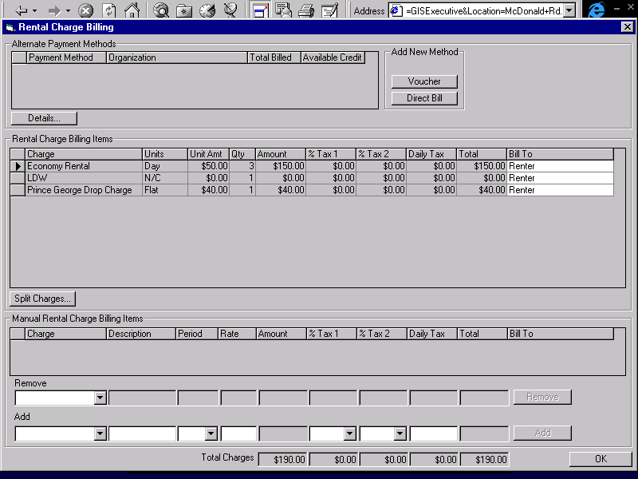
Summary of Changes
A period and rate field will be added to the Manual Charge Billing section. The period will be selection only and will be one of Daily, Weekly or Flat. The amount field will no longer be enterable and will be calculated based on the period, the rate and the length of the rental. If a manual charge item has a daily or weekly rate, but does not cover the entire length of the rental, it will have to be added with a period of Flat and a Rate equal to the total amount being charged.
When LDW is added as a manual charge item, the deductible should be entered as part of the description. This will be a procedural issue and will not be enforced by GIS.

Alternate Payment Details Sub-Screen (Loss of Use)
Summary of Changes
No changes needed for rent backs or interbranch.

Alternate Payment Details Sub-Screen (Direct Bill)
Summary of Changes
No changes needed for rent backs or interbranch.

Alternate Payment Details Sub-Screen (Voucher)
Summary of Changes
No changes needed for rent backs or interbranch.

Split Rental Charge Sub-Screen
Summary of Changes
No changes needed for rent backs or interbranch.

Deposit/Refund Record Screen
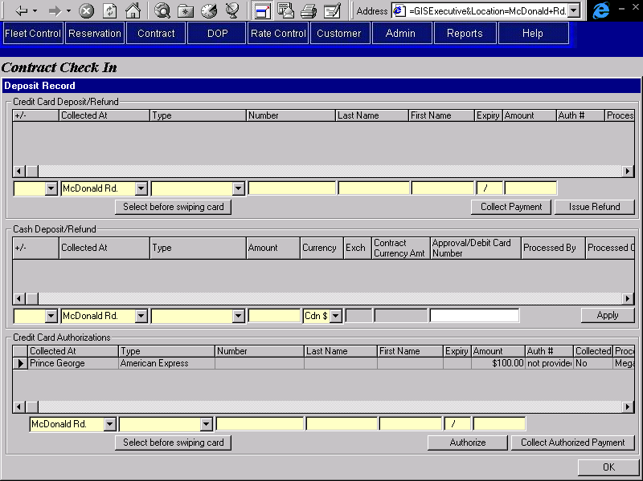
Summary of Changes
The current Deposit/Refund screen will be used for all contracts, regardless of renting location, closing location and vehicle owning company. It will be expanded to include the location where the deposit, payment, refund or authorization was taken. This will default to the user’s current location. The location can be changed to any foreign location on GIS. Entries made in this screen will be saved on GIS in the regular authorization and payment entities, but if the location does not belong to BRAC, the interface to accounting will be treated differently as these will represent payments against the contract, but not direct payments to BRAC.
The currency for all cash payments will default to the contract currency. If another currency is selected, the amount entered will be converted into the contract currency.
This is being kept as one screen because even contracts where the renting location, closing location and vehicle are all BRAC can have changes and payments made at non-BRAC locations.
- Credit Card Deposit/Refund Section
  - The currency for all credit card deposits, payments and refunds will be the contract currency.
  - If the location is BRAC:
If the contract currency is not Cdn $, the Collect Deposit/Payment & Issue Refund buttons will be invisible and all the fields in this section will be locked. The user will be able to scroll to review payments that have already been made, but will not be able to enter new information.
  - If the location is not BRAC:
The Collect Deposit/Payment & Issue Refund buttons will open the manual credit card transaction screen regardless of the credit card type. The user will then be able to enter the amount and the authorization number on this screen.
The credit card information will be optional. Credit card deposits and refunds can be recorded without it.
- Credit Card Authorization Section
  - If the location is not BRAC:
The credit card information will be optional. Credit card deposits and refunds can be recorded without it.
  - Authorize
- If the location is not BRAC, the Authorize button will open the manual credit card transaction screen regardless of the credit card type. The user will then be able to enter the amount and the authorization number on this screen.
- If the location is BRAC, the currency for an authorization will be recorded as Cdn $ (the currency used by BRAC), otherwise the currency for an authorization will be recorded as the currency of the contract.
  - Collect Authorized Payment
- If the renting location is not BRAC and the location is BRAC, the Collect Authorized Payment button will be invisible.
- If the location is not BRAC, the Collect Authorized Payment button will open the manual credit card transaction screen regardless of the credit card type. The user will then be able to enter the amount and the authorization number on this screen.
  - The authorization section will be changed to allow authorizations against more than one credit card, but if the renting location is a BRAC location, the credit card information in the authorization section will default to the credit card used to authorize the rental and cannot be changed.
Question: Do we need to allow authorizations against more than one credit card even if the renting location is BRAC? Resolution: Authorizations are only taken against one credit card (the credit card used to authorize the rental) for contracts where the renting location is BRAC. Multiple credit cards may be used for collection and refund only.
If other owning companies handle one way rentals the same way as BRAC, they would do an authorization on the new credit card if the customer decided to pay with another credit card at check in. We would then have to record that authorization and collect the payment against it.

Discount / Reimbursement Screen
Summary of Changes
No changes needed for rent backs or interbranch.
Question: do we need to record currency for reimbursements, or should they all be in the currency of the contract? Answer: All reimbursements will be assumed to be in the currency of the contract.

Extension History Screen
Summary of Changes
No changes needed for rent backs or interbranch.

Vehicle Replacement History Screen
Summary of Changes
No changes needed for rent backs or interbranch.

Coverage History
Summary of Changes
No changes needed for rent backs or interbranch.

Non-GIS Rate Details Screen - New
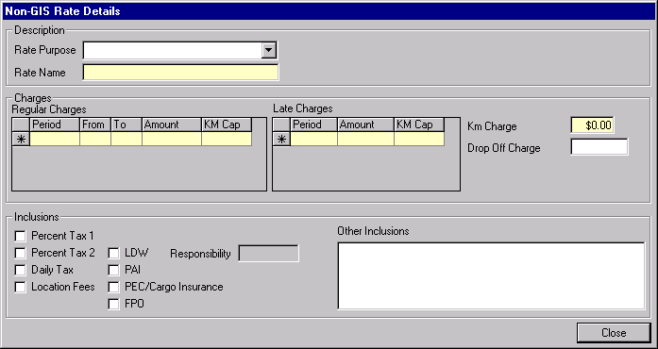
Purpose
The non-GIS rate details screen is used to enter and view the rate details used for contracts where the renting location is not BRAC and to view the rate details for rates from Maestro Reservations.
Navigation
N/A
Functions
N/A
Controls
Req*: Y – always mandatory
N – always optional
S – sometime optional (see Comments for details)
D – display only
Field | Source | Req* | Validation | Comments
Rate Purpose | Quoted Vehicle Rate, Rate Purpose ID | N | Selection only.  Entry controlled by Rate Purpose table.
Rate Name | Quoted Vehicle Rate, Rate Name | Y
Regular Charges
Period | Quoted Time Period Rate, Time Period (Type = ‘Regular’) | Y | Value controlled by Time Period table. | At least one Period with Type = Regular must be specified per rate. A Start and End value must be defined for each Period defined. Start and End periods for time periods of the same value and Type cannot overlap and must be continuous between Periods.
Start | Quoted Time Period Rate, Time Period Start | S | Numeric | Required when Period is entered for the row.
End | Quoted Time Period Rate, Time Period End | S | Numeric | Required when Period is entered for the row.  At least one regular time period must have an end value of ‘9999’.
Amount | Quoted Time Period Rate, Amount | S | Currency | Required when Period is entered for the Row.
Km Cap | Quoted Time Period Rate, Km Cap | S | Numeric or ‘Unlimited’ | Default: Unlimited  Required when Period is entered for the row.
Late Charges
Period | Quoted Time Period Rate, Time Period (Type = ‘Late’) | Y | Value controlled by Time Period table.
Amount | Quoted Time Period Rate, Amount | S | Currency | Required when Period is entered for the row.
Km Cap | Quoted Time Period Rate, Km Cap | S | Numeric or ‘Unlimited’ | Default: Unlimited  Required when Period is entered for the row.
Km Charge | Quoted Vehicle Rate, Per Km Charge | Y | Currency | Default: 0
Drop Off Charge | Quoted Vehicle Rate, Authorized Drop Off Charge | N | Currency
Inclusions
Percent Tax 1 | Quoted Vehicle Rate, GST Included | N |  | Disabled if Maestro Taxes Included check box is visible and not checked.
Percent Tax 2 | Quoted Vehicle Rate, PST Included | N |  | Disabled if Maestro Taxes Included check box is visible and not checked.
Daily Tax | Quoted Vehicle Rate, PVRT Included | N |  | Disabled if Maestro Taxes Included check box is visible and not checked.
Location Fees | Quoted Vehicle Rate, Location Fee Included | N
Maestro Taxes Included | Quoted Vehicle Rate, Tax Included |  |  | Invisible unless rate information is from Maestro.
LDW | Quoted Included Optional Extra, Optional Extra ID | N |  | Turned on if a Quoted Included Optional Extra with a Type of LDW exists.
Responsibility | Quoted Included Optional Extra, LDW Deductible | S | Currency  Must be >= zero | Required if LDW Included is Yes.
PAI | Quoted Included Optional Extra, Optional Extra ID | N |  | Turned on if a Quoted Included Optional Extra with a Type of PAI exists.
PEC/Cargo Insurance | Quoted Included Optional Extra, Optional Extra ID | N |  | Turned on if a Quoted Included Optional Extra with a Type of PEC or Cargo Insurance exists (depending on Vehicle Type for the Vehicle Class selected).
FPO | Quoted Vehicle Rate, FPO Included | N
Other Inclusions | Quoted Vehicle Rate, Other Inclusions | N |  | Not used by GIS, for information only.

Reports
No changes needed for rent backs or interbranch.

Batch Processes
No changes needed for rent backs or interbranch.

Functions

Calculate Non-GIS Rental Charges function
This function will behave in the same way as the Calculate Rental Charges function, with the following exceptions:
- Use Percentage Tax 1, Percentage Tax 2 and Daily Tax in place of GST, PST & PVRT.
- The rate information will be taken from the non-GIS rate information entered for the contract, not from the Rate table.
- There will never be a violation rate.
- There will never be a flex discount or member discount.
- The location surcharges that can be set with the rate will not be present.
- If the renting location is not BRAC, FPO charges will be calculated from the FPO charge amount entered in the Contract Open/Check Out - Renter tab and the Contract Changes During Rental - Replace Vehicle tab.
- Drop charges will be calculated only from the Drop Charge amount entered in the Non-GIS Rate Information screen. Unauthorized drop charges will be entered as manual charge items.
- There will be no upgrade charges, optional extra charges, additional driver charges or sales accessory charges. These will all be entered as manual charge items.

Summary of What GIS will Allow for Authorizations, Deposits, Payments & Collections Against Authorizations
GIS Contract Open/Check Out Screen
Renting Loc |  | Currency | CC Auth | Collect from  CC Auth | CC Deposit/  Payment | Cash Deposit/  Payment
BRAC |  | Cdn $ | Yes (process) | N/A | Yes (process) | Yes (process)
Foreign |  | Cdn $ | Yes (record) | Yes (record) | Yes (record) | Yes (record)
Foreign |  | US $ | Yes (record) | N/A  Yes (record) | Yes (record) | Yes (record)
GIS Contract Changes During Rental Screen
Renting Loc | Change Loc | Currency | CC Auth * | Collect from  CC Auth | CC Deposit/  Payment | Cash Deposit/  Payment
BRAC | BRAC | Cdn $ | Yes (process) | Yes (process) | Yes (process) | Yes (process)
Foreign | BRAC | Cdn $ | Yes (process) | No | Yes (process) | Yes (process)
Foreign | BRAC | US $ | Yes (process in Cdn $) | No | No | Yes (process)
BRAC | Foreign | Cdn $ | Yes (record) | Yes (process) | Yes (record) | Yes (record)
Foreign | Foreign | Cdn $ | Yes (record) | Yes (record) | Yes (record) | Yes (record)
Foreign | Foreign | US $ | Yes (record) | Yes (record) | Yes (record) | Yes (record)
GIS Contract Check In Screen
Renting Loc | Check In Loc | Currency | CC Auth * | Collect from  CC Auth | CC Deposit/  Payment | Cash Deposit/  Payment
BRAC | BRAC | Cdn $ | Yes (process) | Yes (process) | Yes (process) | Yes (process)
Foreign | BRAC | Cdn $ | Yes (process) | No | Yes (process) | Yes (process)
Foreign | BRAC | US $ | Yes (process in Cdn $) | No | No | Yes (process)
BRAC | Foreign | Cdn $ | Yes (record) | Yes (process) | Yes (record) | Yes (record)
Foreign | Foreign | Cdn $ | Yes (record) | Yes (record) | Yes (record) | Yes (record)
Foreign | Foreign | US $ | Yes (record) | Yes (record) | Yes (record) | Yes (record)
process: GIS will process through Eigen (if applicable) and will pass to accounting as payment received by Budget BC (for deposits & payments). See the Contracts Part 1 document for accounting details.
record: GIS will not process through Eigen and will not pass to accounting as payment received by Budget BC (for deposits & payments) – what will be passed to accounting is documented in the Contracts Part 1 document.
* CC Auth: only applies if the rental was authorized with a credit card and no deposits of any kind have been collected during the rental

Revision History

Version 2.00
- Clean up documentation and make consistent with the GIS standards.

